**Business Context**: A regional retail company operating in Rwanda's major regions (Kigali, Northern, Southern, Eastern, Western) needs to analyze their sales performance across different product categories to optimize inventory management and marketing strategies.

**Data Challenge**: The company has accumulated 2 years of transactional data but lacks analytical capabilities to identify regional sales patterns, product performance trends, and customer purchasing behaviors. They need to understand which products perform best in each region, track sales growth, and segment customers for targeted marketing.

**Expected Outcome**: Therefore, this is to guide in regional inventory allocation, identify growth opportunities in underperforming regions, and create targeted customer segments for personalized marketing campaigns.

Step 2

* **Top 5 products per region per quarter: using RANK()** to identify regional best-sellers
* **Running monthly sales totals: using SUM() OVER()** to track cumulative performance
* M**onth-over-month growth rates: using LAG()** to analyze sales trends
* **Customer spending quartiles: using NTILE(4**) for segmentation
* **3-month moving averages: using AVG() OVER()** to smooth seasonal fluctuations

Step 3

1. Customer table

CREATE TABLE customers (

customer_id NUMBER PRIMARY KEY,

name VARCHAR(100),

region VARCHAR(50)

);

1. Product table

CREATE TABLE products (

product_id NUMBER PRIMARY KEY,

name VARCHAR2(100),

category VARCHAR2(50)

);

1. Transaction table

CREATE TABLE transactions (

transaction_id NUMBER PRIMARY KEY,

customer_id NUMBER,

product_id NUMBER,

sale_date DATE,

amount NUMBER(10,2),

FOREIGN KEY (customer_id) REFERENCES customers(customer_id),

FOREIGN KEY (product_id) REFERENCES products(product_id)

);

Step 4

1. Ranking

We ranked these by total spending, within category, sales performance, by usage and number of visits

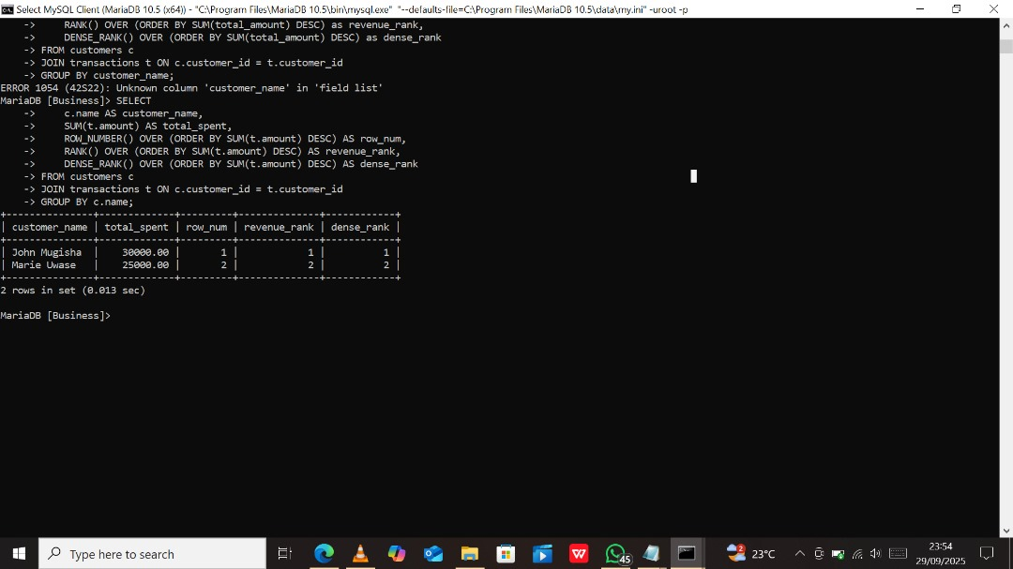

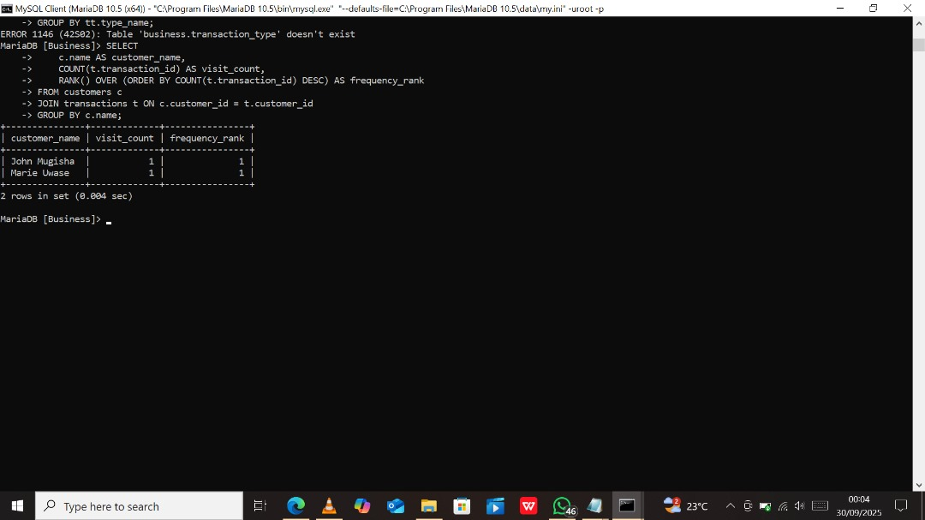

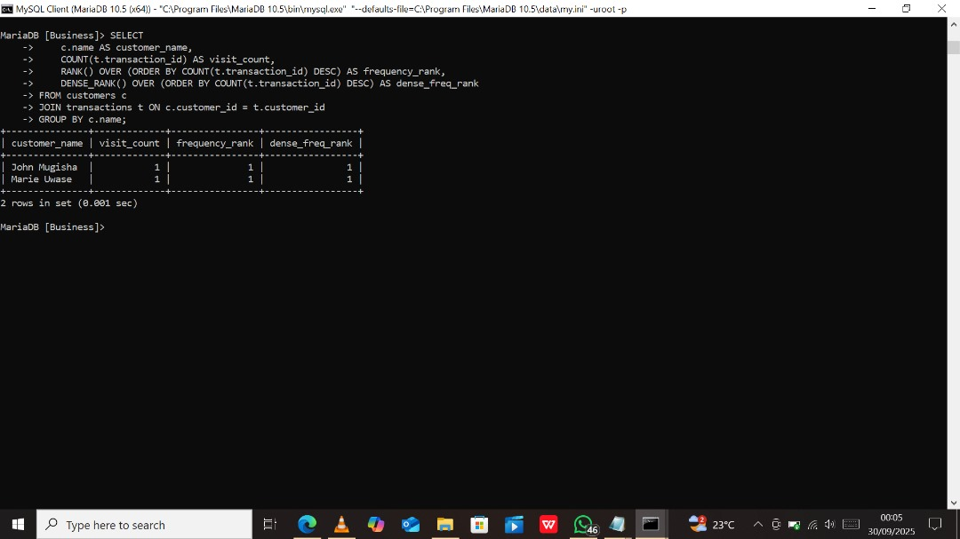

1. Aggregate

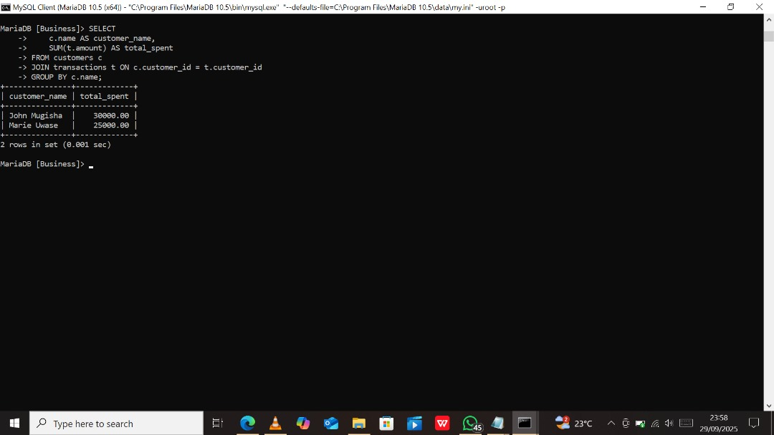

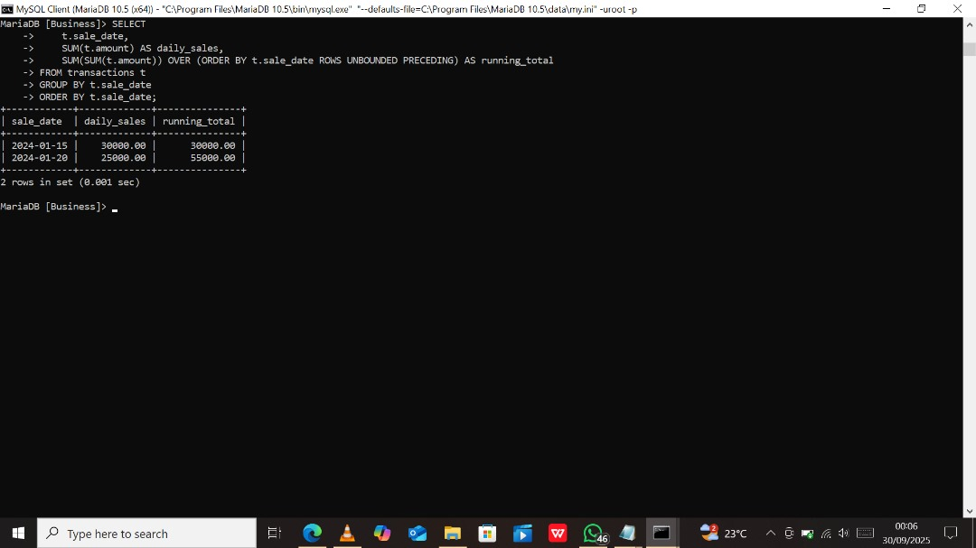

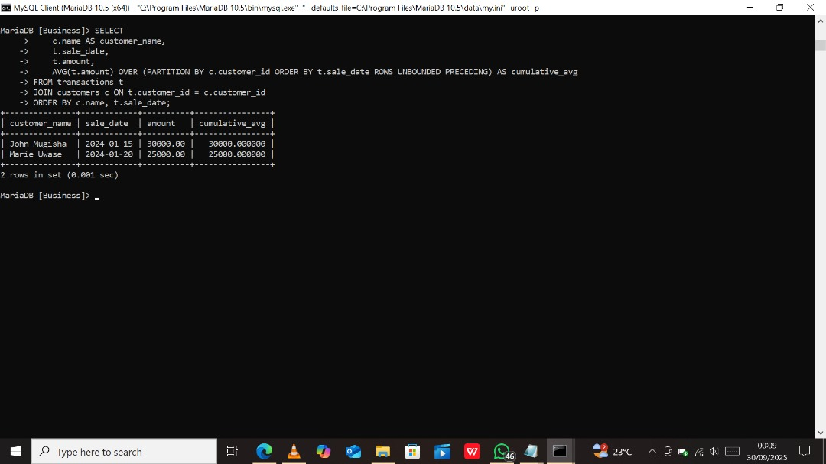

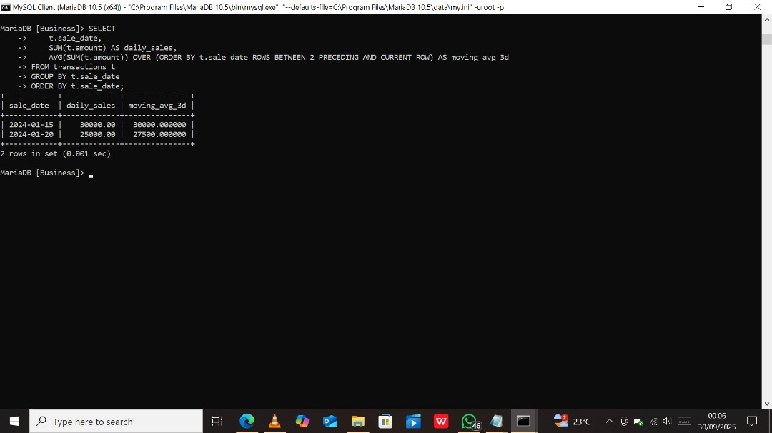

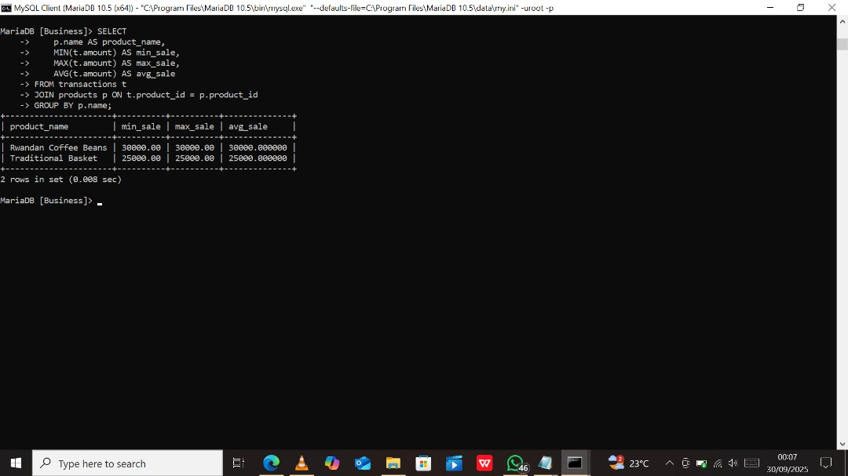

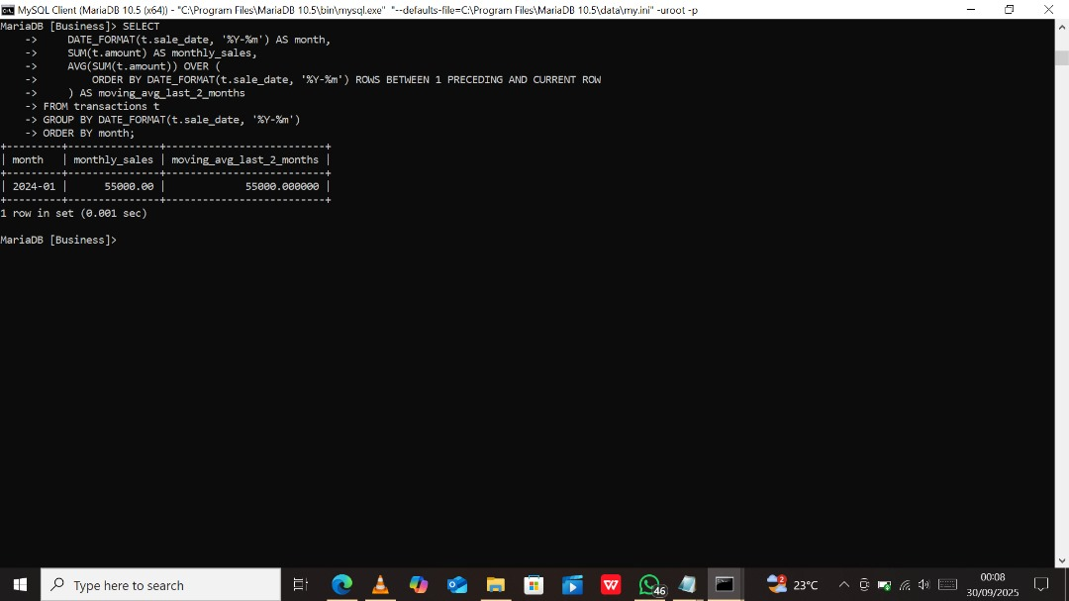

1. Navigation

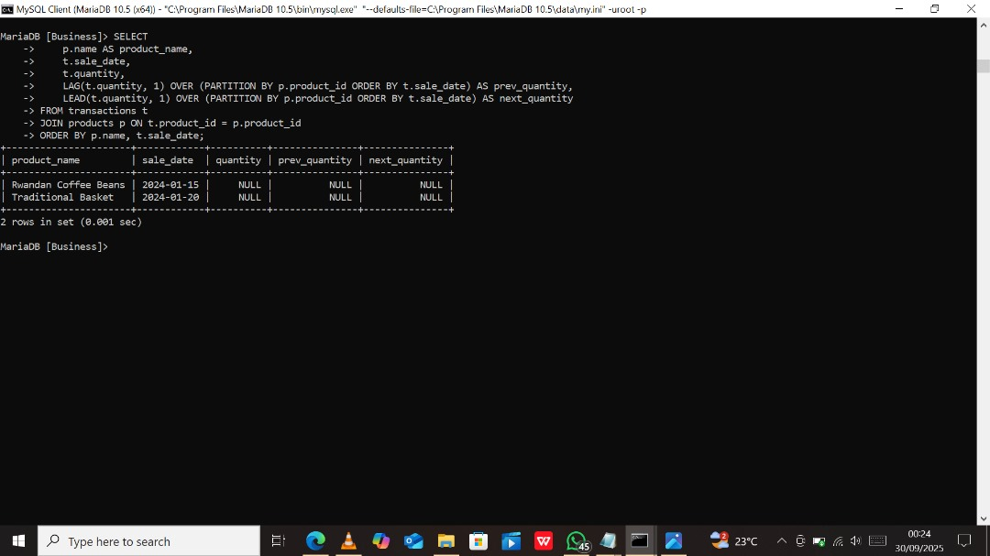

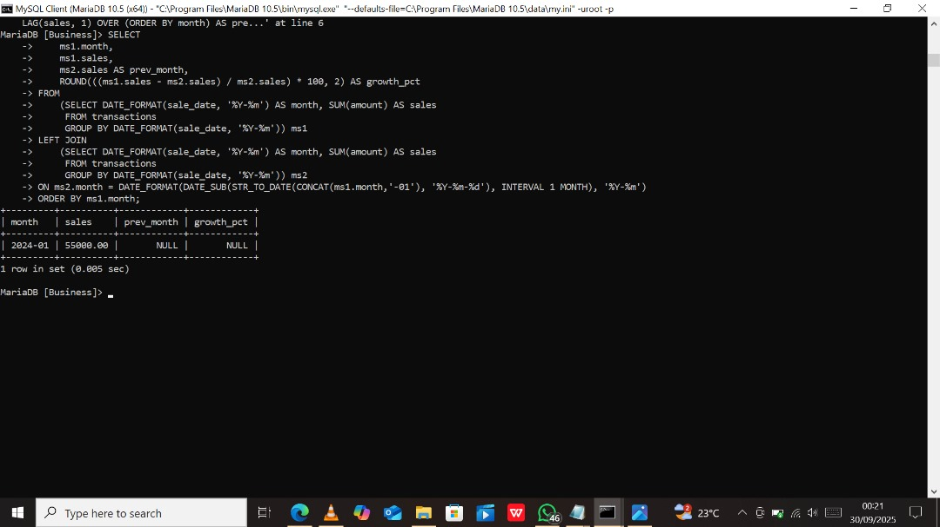

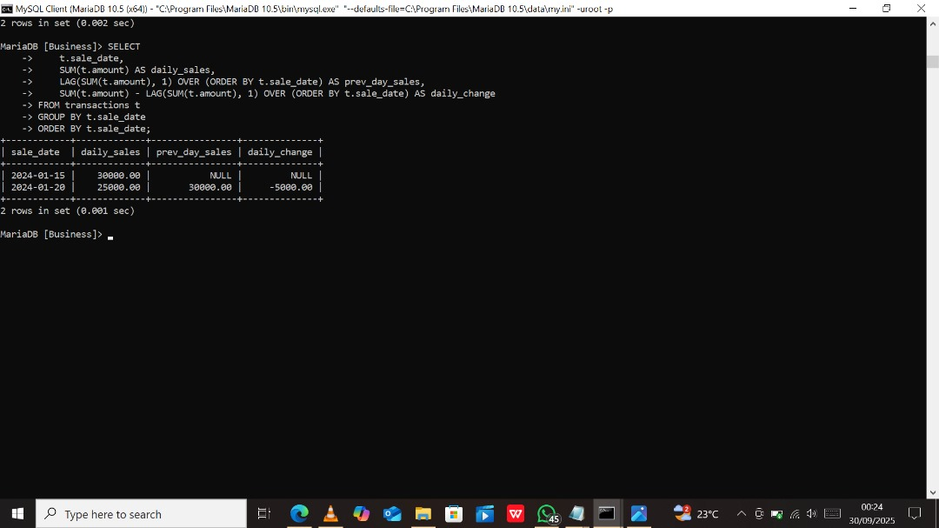

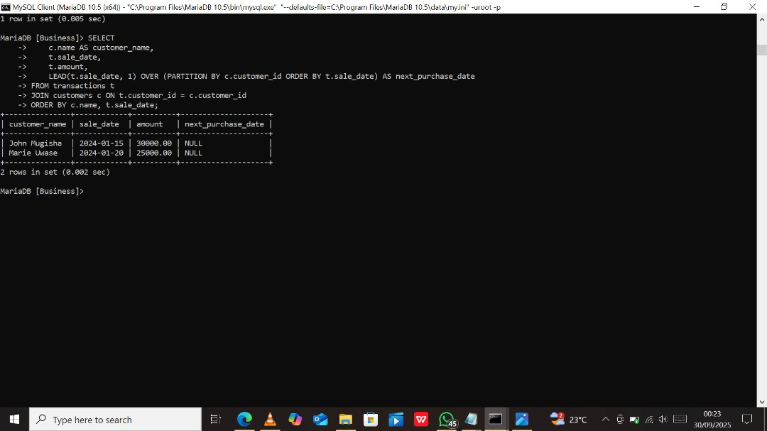

1. Navigation

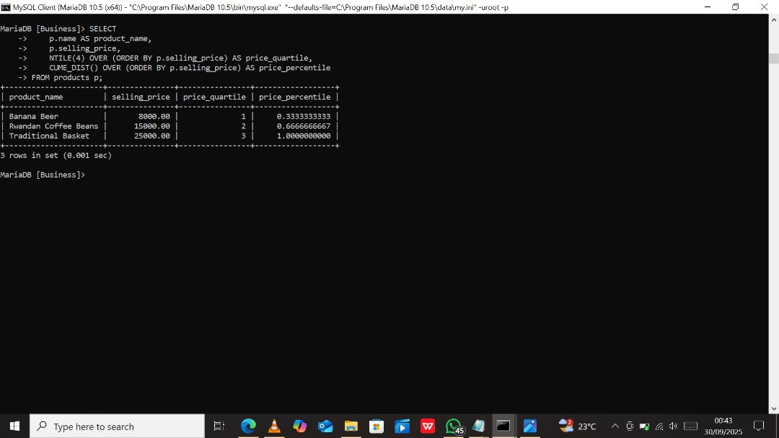

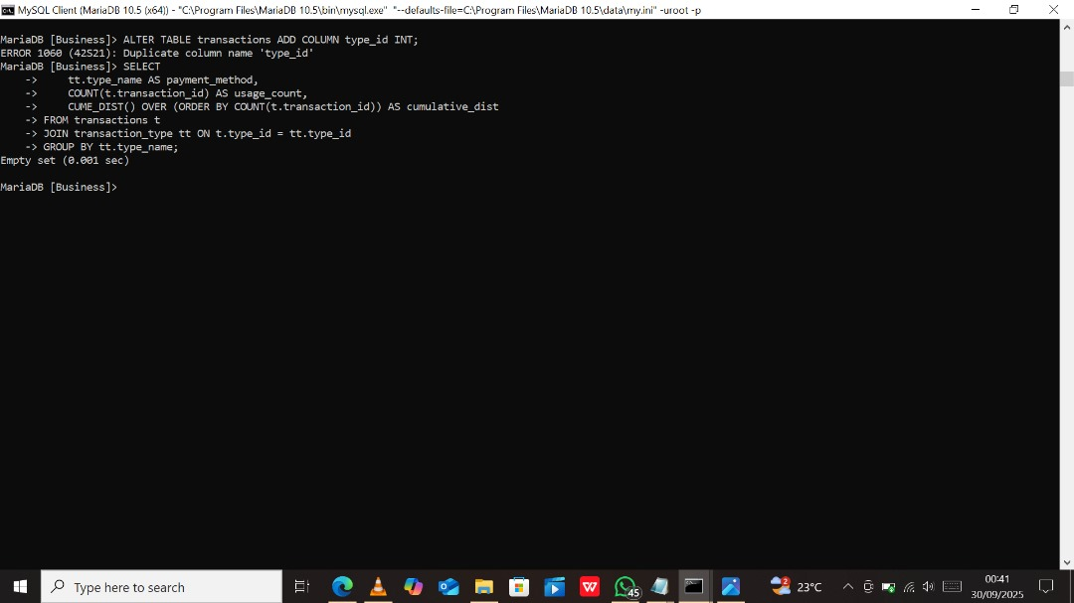

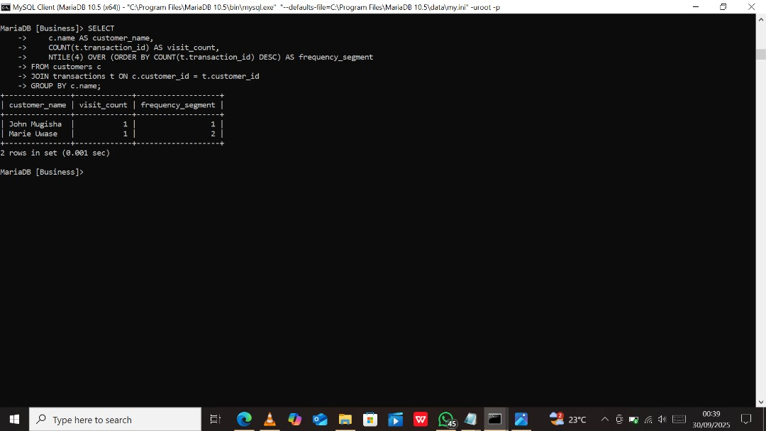

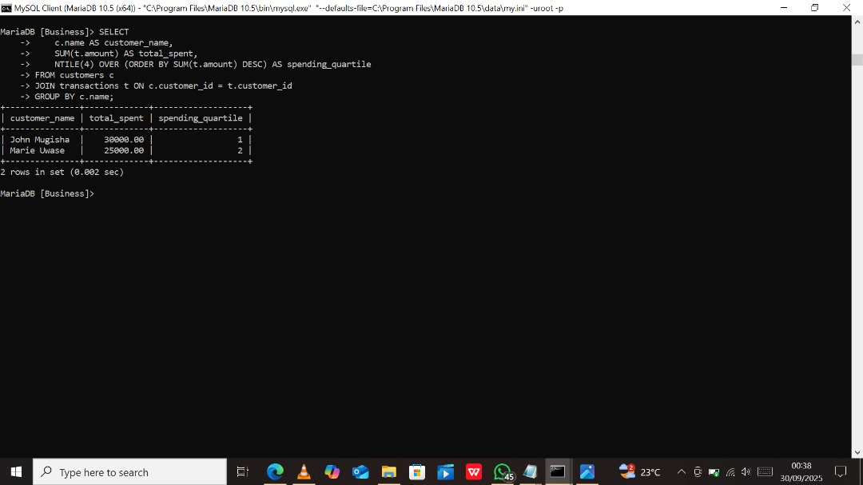

Descriptive Analysis

Kigali region contributes 45% of total revenue, indicating market concentration

Beverages category shows 15% month-over-month growth in Q1 2024

Top 5 products account for 60% of regional revenue across all regions

Diagnostic Analysis

Northern region underperformance linked to limited product distribution

Seasonal spikes in December correlate with holiday shopping patterns

Customer retention drops after 3 months without engagement

Prescriptive Analysis

Inventory Optimization: Increase stock of top-performing products in Kigali by 30%

Regional Expansion: Develop targeted marketing for underperforming Northern region

Customer Retention: Implement loyalty program for Gold and Premium segments

Product Strategy: Expand Beverages category based on consistent growth trends